Project Design Phase-II

Data Flow Diagram & User Stories

|  |  |
| --- | --- |
| Date | 14 october 2022 |
| Team ID | PNT2022TMID13904 |
| Project Name | Project - CONTAINMENT ZONE ALERTING APPLICATION |
| Maximum Marks | 4 Marks |

# Data Flow Diagrams:

A Data Flow Diagram (DFD) is a traditional visual representation of the information flows within a system. A neat and clear DFD can depict the right amount of the system requirement graphically. It shows how data enters and leaves the system, what changes the information, and where data is stored.

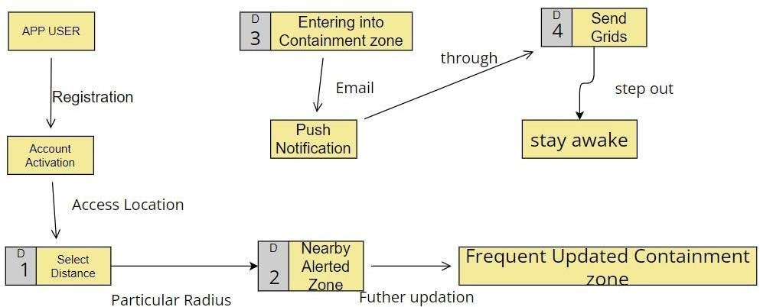

# User Stories

Use the below template to list all the user stories for the product.

|  |  |  |  |  |  |  |
| --- | --- | --- | --- | --- | --- | --- |
| **User Type** | **Functional Requirement**  **(Epic)** | **User Story Number** | **User Story / Task** | **Acceptance criteria** | **Priority** | **Release** |
| Customer (Mobile user) | Registration | USN-1 | As a user, I can register for the application by entering my email, password, and confirming my password. | I can access my account / dashboard | High | Sprint-1 |
|  |  | USN-2 | As a user, I will receive confirmation email once I have registered for the application | I can receive confirmation email & click confirm | High | Sprint-1 |
|  |  | USN-3 | As a user, I can register for the application through Facebook | I can register & access the dashboard with Facebook Login | Low | Sprint-2 |
|  |  | USN-4 | As a user, I can register for the application through Gmail |  | Medium | Sprint-1 |
|  | Login | USN-5 | As a user, I can log into the application by entering email & password |  | High | Sprint-1 |
|  | Dashboard | USN - 6 | user Can I manually plot the alerted zone for my convenience only. | It can be viewed in the user dashboard | Low | Sprint - 2 |
| Customer (Web user) | Registration | USN-1 | As a user, I can register for the application by entering my email, password, and confirming my password. | User account activities can be viewed in dashboard. | High | Sprint - 2 |
|  |  |  | Confirmation code has been send through the registered mail id and phone number |  |  |  |
|  | Location Access | USN - 2 | As a user I can viewed into the page , if there is any condition to access the location | Location can be turned through Control center | High | Sprint - 2 |
|  | Contaminated Zones | USN - 3 | Is it accurately show off the alerted zone If I entered into the zone the messages are properly received through email. | Alerted messages are send by send grids through the registered mail id | High | Sprint - 3 |
| Administrator | Frequent Updates | USN - 4 | Admin are necessary to updates the recent  containment through their portals and these seen throught the app. | It can be accessed by Geo fencing. | Medium | Sprint - 4 |